# **Version 3: 08/04/2020**[Image result for gig cymru nhs wales logo](https://www.google.co.uk/url?sa=i&url=https://www.cardiff.ac.uk/professional-development/case-studies/nhs-wales-finance-academy&psig=AOvVaw1HayXDTcao_14XErfs_GAG&ust=1584991545907000&source=images&cd=vfe&ved=0CAIQjRxqFwoTCIDciuPnrugCFQAAAAAdAAAAABAO)

**COVID-19**

**PRIMARY AND COMMUNITY CARE GUIDELINE**

**IMPLEMENTATION PLANA**

**CHANGES TO VERSION 3:**

1. **References to support decision tree: page 8**
2. **NICE guidance on application of the clinical frailty score: p19**

**Version Control table:**

|  |  |  |  |
| --- | --- | --- | --- |
| **Version** | **Date** | **Changes** | **Attachments** |
| 1 | 23/03/2020 | N/A | Covering letter AG Community telephone consultation LTC-COVID 19 Wellbeing support at home |
| 2 | 31/03/2020 | * P6 flowchart: “admit to hospital” now clarified to “admit to acute hospital” * P6 rising respiratory rate reduced from >25 to >24 * Advice to use airflow to the face eg a fan has been removed. This is no longer advised. | Covering letter  Home oxygen |
| 3 | 08/04/2020 | * P8 References to support decision tree: * P19 NICE guidance on application of the clinical frailty score | NICE guidance on application of the clinical frailty score      Full NICE guidance (03/04/2020)  <https://www.nice.org.uk/guidance/ng165> |

# **THE PRE-HOSPITAL MANAGEMENT OF COVID-19 INFECTION**

# Pathway Purpose

The purpose of this pathway is to support primary care, community and paramedic colleagues in decision making regarding the management of patients presenting with suspected or actual Covid-19.

# Who will use it?

This entire framework/pathway is to be used by any doctor, nurse, paramedic or allied health professional, anywhere in the community. Local Health Boards and Clusters will plan and deliver their services differently according to local needs and workforce, but will follow this framework.

# Management Aim

We aim to treat all patients in a setting that is appropriate to their specific personal needs, whilst maintaining a functioning healthcare system in extraordinary circumstances. The framework provides a consistent approach to the management of patients during the Covid-19 Pandemic and is aligned to the all Wales secondary care guidance. It also complements PHW primary care guidance.

# The Four Key Health Care Actions in the Community

1. Self-Care and Self-management at home
2. Supportive Care delivered in the home, GP surgery or cluster hub by a multi-professional team serving a cluster population
3. Palliative care delivered in the home, probably by a multi-professional cluster supportive care team
4. Referral to an acute hospital

**KEY ASSUMPTIONS AND ENABLERS**

Our ability to provide care as the number of patients infected with Covid-19 rises depends on a whole system approach to management. This model assumes that:

* That senior expert advice will be readily available by telephone
* That we have access to patient information resources regarding prognosis/clinical reasoning
* The pathways are based on an ethical framework
* That a Single Point of Access is available 24/7 for urgent referrals to the Cluster Supportive Hub Service and Palliative Care Service
* That Cluster Hub Supportive and Palliative Care services are able to respond rapidly within 2 hours of a call and work collaboratively 24/7
* That capacity and sickness is actively tracked on a daily basis to enable new staff to redeploy and backfill gaps
* That non-essential and admin tasks are removed from clinicians (consider redeploying non-clinical staff to act as scribes, runners, etc)
* That enhanced respiratory training is made available
* That clinical governance arrangements are locally determined and may need to change during the course of the pandemic.

Some patients are more likely to develop complications of Covid-19 and require management which will be personalized according to their existing conditions and circumstances.

## Higher Risk Categories

* Elderly
* Multi-morbidity
* Long term conditions
  + Respiratory
  + Cardiovascular, including Hypertension
  + Diabetes
  + Immunosuppressed

# **Key actions can be taken in advance**

* Optimise the ability of the patient to resist infection and reduce complications.
* Optimisation of Long Term Conditions through clinical review and self-management
  + COPD
  + Asthma
  + Diabetes
  + Hypertension
  + Cardiovascular disease
* Optimisation of Frailty
  + Medication reviews
* Co-produce an Advance Future Care Plan (with or without a DNA-CPR) that clearly describes the ceilings of treatment for the patient if possible

**THE PRE-HOSPITAL ALGORITHM FOR COVID-19 INFECTION**

This Community Framework/Pathway should be read in conjunction with the interim PHW guidance for Primary Care



**Patient feels they cannot cope with their symptoms at home**

**or**

**Patient condition gets worse**

**or**

**Symptoms do not get better after 7 days**

**Self-Care at Home**

**(for 7 days)**

**With safety-netting**

**A high temperature? or**

**A new continuous cough?**

**NHS Wales**

**111** **Online**

**New Concerns or Symptoms**

**Patient Calls**

**Own GP for**

**Telephone or Video assessment**

**Telephone or Video assessment**

NHS 111 Wales or Pre-hospital clinician

**Measure temp, pulse, BP, O2 sats and RR**

Look for signs of respiratory distress - rising respiratory rate >24 and falling SpO2<94% if no pre-existing respiratory disease (or 4% below baseline if known)

**Admit to Acute hospital**

**Discuss with front door clinician and admit/treat accordingly**

NO

YES

**Physical Clinical Assessment Required**

In designated room in GP Practice or Cluster Hub or at home, using PPE

at local Hub or home using PPE

**Patient requires emergency treatment and is likely to benefit from ICU escalation\***

**Use the three questions on page 7 to guide which action or service is most likely to meet your patient’s needs**

**Self-Care at Home with safety- netting**

**No further assessment needed**

If you are unsure if your patient should stay at home, we encourage you to speak to a colleague or **contact the local specialist advice line**. Document all discussions.

**Does your patient meet criteria for respiratory distress?**

**\*Evidence shows that the following groups do not respond well to ICU escalation:  
Clinical Frailty Score of 5 or above (see link page 17 and further NICE guidance)  
Chronic severe cardiac or respiratory disease and other severe co-morbidities  
On home oxygen or undergoing palliative chemotherapy**Loughlin PC, Sebat F, Kellett JG. Respiratory Rate: The Forgotten Vital Sign—Make It Count!.  
 Joint Commission journal on quality and patient safety. 2018 Aug 1;44(8):494-9.  
Ganfure GO. Using video stream for continuous monitoring of breathing rate for general setting.   
Signal, Image and Video Processing. 2019 Oct 1;13(7):1395-403.

**Discuss admission with front door clinician and admit /treat accordingly**

**Cluster Hub Supportive Care at Home with care plan**

NO

YESS

**Admit to Acute Hospital**

**Is patient likely to benefit from ICU escalation?\***

**NO**

**Palliative Care at Home**

**Cluster Hub Supportive Care at Home**

**Yes**

**Does patient have an advance future care plan that applies in this case?**

* 1. YES – go to supportive/palliative care (community hub or Idris’ pathway)

1. Does patient have conditions or circumstances that mean

secondary care admission is not likely to help?

* 1. NO – go to 4
  2. YES - provide supportive/palliative care (community hub or idris’ pathway)

1. Admit as emergency

**NO**

**Symptom relief, Self-Care at Home with active monitoring**

**Involve cluster hub for social/nursing needs**

Yes

**YES**

Self-Care & Self-Management at Home

**This pathway links to Self-isolation advice which can be accessed via:**

<https://phw.nhs.wales/topics/latest-information-on-novel-coronavirus-covid-19/what-to-do-if-you-have-symptoms-of-coronavirus/>

<https://assets.publishing.service.gov.uk/government/uploads/system/uploads/attachment_data/file/872745/Infection_prevention_and_control_guidance_for_pandemic_coronavirus.pdf>

**Cluster Hub Referral Pathway**

Referrers:

Operational Hours:

**0** 123

**The following PPE MUST BE USED for consultations of acute respiratory infection or influenza like illness**

* **Fluid Resistant Surgical Mask (FRSM)**
* **Disposable gloves**
* **Disposable plastic apron**
* **Appropriate eye protection, after risk assessment of need, if splashing or spraying of body fluids likely.**

**For aerosol generated procedures (AGP) e.g. NIV/CPAP or suctioning YOU MUST use**

* **FFP3 masks**
* **Disposable gowns**
* **Visors**
* **Disposable gloves**

**PPE MUST BE USED IN CONJUNCTION WITH EFFECTIVE HAND HYGIENE**

**For further information please refer to:**

[https://www.gov.uk/government/publications/wuhan-novel-coronavirus- prevention-and-control](https://www.gov.uk/government/publications/wuhan-novel-coronavirus-infection-prevention-and-control) infection-

Referrer contacts team via SPA and provides patient details

Referrer responsible for next course of action

**NO**

Patient meets criteria and has consented to referral



**YES**

Referral logged by administration, triaged by Cluster Hub Support Team and allocated a telephone consultation appointment depending on urgency

SPA to transfer HCP to Frailty Rapid team for a clinical discussion

Patient contacted via telephone using All Wales Telephone Consultation Form. Clinical intervention and further management dictated by patient’s clinical condition

Home visit required

Patient well and discharged with stay at home advice

Palliative Care

Discharged with Stay at home advice

Further telephone call

Continue intervention as clinically indicated

# **Please see appendices for additional cluster hub resources:**

1. Patient Information Leaflet- Long term condition and pregnancy
2. Well-being support at Home
3. All Wales Community consultation form

Palliative Care at Home

**Palliative care guidance in the context of Covid-19 epidemic**

Palliative and end of life care in the community for patients who have suspected severe COVID-19 infection, where not admitting to hospital is being considered, and who are at risk of deterioration and death.

* Advance & future care planning (ACP/FCP)
  + If the patient is able to participate in decision making, support them to do so.
  + If they are not able to, find out whether any ACP/FCP or any kind of statement of wishes has been written and make use of it. For instance if there are clinical reasons not to admit, knowing that the person wanted to avoid hospital admission may make the decision and the discussion of it easier. Follow guidance on how to use.
  + If there is none, think about whether there’s a chance to help write down any preferences or priorities the person has. Follow guidance on how to do this.
* Symptom control
  + **Summary:** 
    - **For breathlessness and anxiety, give a stat dose of morphine 2.5mg + midazolam 2.5mg by injection then start continuous infusion of morphine 10mg + midazolam 10mg over 24h by infusion via a syringe driver.**
    - **If already on a regular opioid, bigger starting doses may be needed – see footnotes to table.**
    - **Use subsequent PRN doses freely.**
    - **Consider increasing both syringe driver and PRN doses if PRNs are needed frequently, or if the response is incomplete. Seek advice if this doesn’t work.**
    - **If there is concern about drug toxicity, *eg* respiratory depression, seek advice.**
    - **Remember that deterioration including a fall in conscious level is to be expected and does not mean toxicity. This pattern in severe COVID-19 infection, in those patients who are not expected to benefit from escalation, is likely to represent deterioration in condition not drug toxicity.**
  + Experience of palliative and end of life care in severe COVID-19 infection is developing rapidly. Please look out for updates to this guidance and use the most recent version.
  + What we know so far is that severe COVID-19 infection can cause severe and distressing symptoms that should respond well to quick use of commonly used symptom control drugs. Because patients may become very symptomatic very quickly, and deteriorate quickly, symptom control is very urgent.
  + General tips
    - Look for the common symptoms & ask if there are any others.
    - Establish what the priorities are. Usually at the end of life good symptom control tops the list.
    - Explain what you’re doing, explain how it serves the priorities, and explain that it is safe.
    - Adjust doses according to response. Some people need much higher doses than others.
    - If they’re already taking regular strong opioids, ignore the starting doses in the table & see footnotes.
    - These principles also work in end of life care for other illnesses.
    - There is more detailed symptom control guidance for non-specialists here.
    - If you need advice having consulted that, ask. Local arrangements are being confirmed.
  + Common treatable symptoms of severe COVID-19 infection include
    - Breathlessness
    - Anxiety
    - Agitation
  + Other symptoms may be due to the infection or due to pre-existing long term or life-shortening conditions
    - Pain
    - Nausea & vomiting
    - Respiratory secretions
  + Injectable drugs are likely to be needed. Subcutaneous is usual first choice but intramuscular is OK. If the patient has suitable oral medications and can take them then these can be used for now but they’re likely to become unable to take them if they deteriorate so don’t rely on these. Sublingual or buccal medications may remain an option as the patient doesn’t need to swallow them, but in acute distress they are harder to use.
  + Sensible use of these drugs is safe and effective. We know that in other conditions good symptom control in end of life care doesn’t hasten death, and although experience of COVID-19 is more limited there is no reason to think it’s different in this respect. Dose titration may be required and sometimes to much higher doses.
  + Some people with severe COVID-19 injection deteriorate very quickly at the end of life. Injected doses work quickly, in about half an hour. Use PRN doses freely to get control of the symptoms the patient has now.
  + These symptoms are expected to be continuous rather than resolving, so if a syringe driver is available use that too to maintain control. Syringe drivers start to work slowly if that’s all you do which is why you need stat & PRN doses too. While syringe drivers are useful, don’t rely on them alone for what the patient needs today. If you are not able to set up a syringe driver, see if a nurse can visit quickly to do so.
  + If no syringe driver is available or if there is no one to set one up, morphine + midazolam should be used at current PRN doses 4 hourly by sc injection via a butterfly if someone is available to give it – this is almost as effective as a driver and painless but needs round the clock doses.
  + If inadequate response, dose increases are likely to be needed. Get advice if necessary.

|  |  |  |  |  |
| --- | --- | --- | --- | --- |
| Symptom | Drug | Route | Starting dose1 (if not already on regular opioid) | Frequency |
| Breathlessness | Morphine6  Use together with midazolam | sc/im | 2.5mg2 | PRN up to hourly |
| sc | Typically 10mg3 | Over 24h by sc infusion |
| Oral4 | 5mg5 | PRN up to hourly |
| Midazolam  Use together with morphine | sc/im | 2.5mg | PRN up to hourly |
| sc | Typically 10mg | Over 24h by sc infusion |
| Lorazepam  Use 1st line if no one to inject | Sublingual | 500 micrograms | PRN up to hourly |
| Oxygen | Any | Freely | Continuous |
| Anxiety & agitation | Midazolam | sc/im | 2.5mg | PRN up to hourly |
| Lorazepam  Use 1st line if no one to inject | Sublingual | 500 micrograms | PRN up to hourly |
| Agitation (if hallucinations or if treating as for anxiety hasn’t worked) | Haloperidol  1st line | sc/im | 1.5mg | PRN up to hourly |
| Sc | Typically 3mg | Over 24h by sc infusion |
| Levomepromazine | sc/im | 12.5mg | PRN up to hourly |
| Sc | 25mg | Over 24h by sc infusion |
| Nausea & vomiting | Haloperidol | sc/im | 1.5mg | PRN hourly |
| Pain | Morphine | sc/im | 2.5mg | PRN up to hourly |
| Po | 5mg | PRN up to hourly |
| Respiratory secretions | Hyoscine hydrobromide | Sc | 400 micrograms | PRN up to 4 hourly |
| Glycopyrronium | Sc | 200 micrograms | PRN up to 4 hourly |

10mg oral morphine = 5mg morphine injection

Doses for pain and breathlessness are the same – keep it simple

1. Patients on regular opioids need, and tolerate, proportionately bigger starting doses – standard doses will not work unless the existing dose is quite small.
2. If already on regular oral morphine, to get the injected dose divide the current PRN oral dose by 2. Alternatively divide the current total daily dose (usually double the dose of 12 hourly oral morphine + any PRN doses) by 12. Either way is fine. Either way, round up – to the nearest 2.5mg if up to 10mg or to the nearest 5 if over 10mg.
3. If already on oral morphine, to get the syringe driver dose take the total current 24 hour dose (usually double the dose of 12 hourly oral morphine + any PRN doses) & divide by 2.
4. This must be immediate release *eg* oramorph, sevredol. Do not use modified release for immediate relief of breathlessness – it takes too long to work.
5. If already on oral morphine, to get the oral dose for breathlessness just use their current PRN dose or divide the current total daily dose (usually double the dose of 12 hourly oral morphine + any PRN doses) by 12.
6. If they are already taking a different strong opioid (*eg* diamorphine, oxycodone, hydromorphone, fentanyl patch), for breathlessness you can use whatever immediate release version they are taking for pain and at the same dose. Give this + either midazolam or lorazepam. If an injection is needed and their usual opioid isn’t available in injection form, just use morphine.

5mg oral oxycodone = 5mg morphine injection.

1.3mg oral hydromorphone = 5mg morphine injection.

Patients on fentanyl patches usually have immediate release morphine or diamorphine or sometimes oxycodone for pain so use that.

You can consult symptom control guidance, or get advice.

Referral to Acute Hospital

# **National Guidance Secondary Care – Covid-19**



**Clinical Frailty Scale**

<https://www.bgs.org.uk/sites/default/files/content/attachment/2018-07-05/rockwood_cfs.pdf>

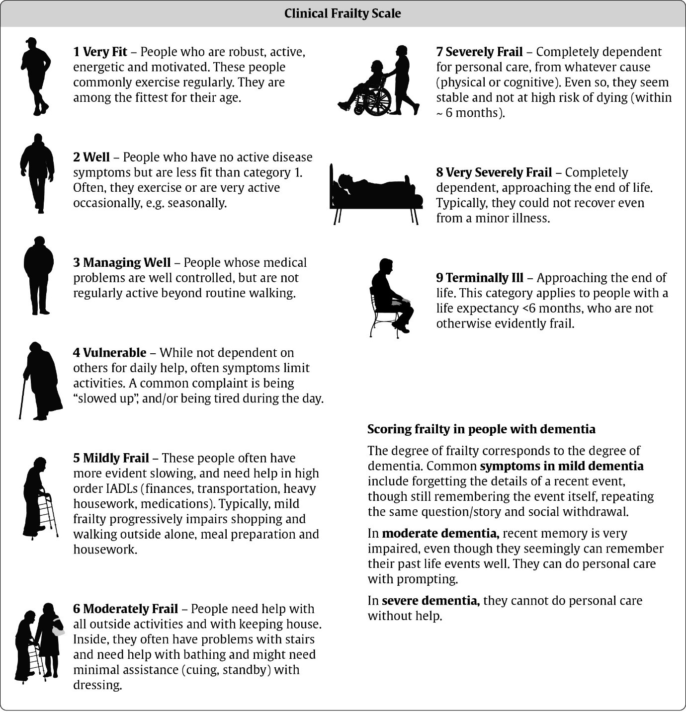

Decisions regarding treatment and hospital admission should be always be made on an individual basis. NICE has issued a further statement on the application of the Clinical Frailty Score :

*“The CFS should not be used in younger people, people with stable long-term disabilities (for example, cerebral palsy), learning disability or autism. An individualised assessment is recommended in all cases where the CFS is not appropriate.”*

**ETHICAL FRAMEWORK**

Ethical summary statement

Some people benefit from rapid escalation to intensive care and ventilation. In some patients this will not work. Some can be identified early. We should use treatments that work, without disproportionate harm, subject to consent or best interest judgments, and provided they can be offered within the resources available. We should not use treatments that do not pass these tests. A treatment, however widely used and well known and however much the patient &/or those close to them think they would want it, should not be used if it stands no real chance of working in a particular patient or if it would cause disproportionate harm. Whatever treatments are being used, each patient should be given the best care available, helping them to survive if that can be achieved, and in all circumstances helping them to be comfortable, to live with dignity, and to be in the place of their choice if that is important to them. Guidance is offered to support decisions about which treatments will help, which will not, and how to maintain comfort. For some patients, there is nothing to gain by being in hospital. The question of what treatment is to be used may therefore help decide where the patient should be. If all the treatment being used can be done at home, and if some care is available, home (including a care home if that is the person’s home) is usually the best place and often the place they would prefer.

The best that is available may be less good than we would want to provide. We should be as flexible as possible to get the patient as comfortable as possible within the limitations we face. There may not be enough capacity to offer every patient every treatment. Decisions not to use a treatment are likely to be needed much more often during a pandemic crisis. Making sure that patients are not given treatments that are not right for them helps them. It also helps the other patients who may then have a greater chance to have treatments that would work. This should be the basis of decisions and is the fairest way to decide when there is not enough to go around.